Before you begin
Make a backup of your device using iCloud or iTunes.

Update your device using iTunes
If you can’t update wirelessly, you can update with iTunes. If your computer uses the Personal Hotspot on the iOS device that you’re updating, connect your computer to a different network.
- Install the latest version of iTunes on your computer.
- Connect your device to your computer.
- Open iTunes and select your device.
- Click Summary, then click Check for Update.

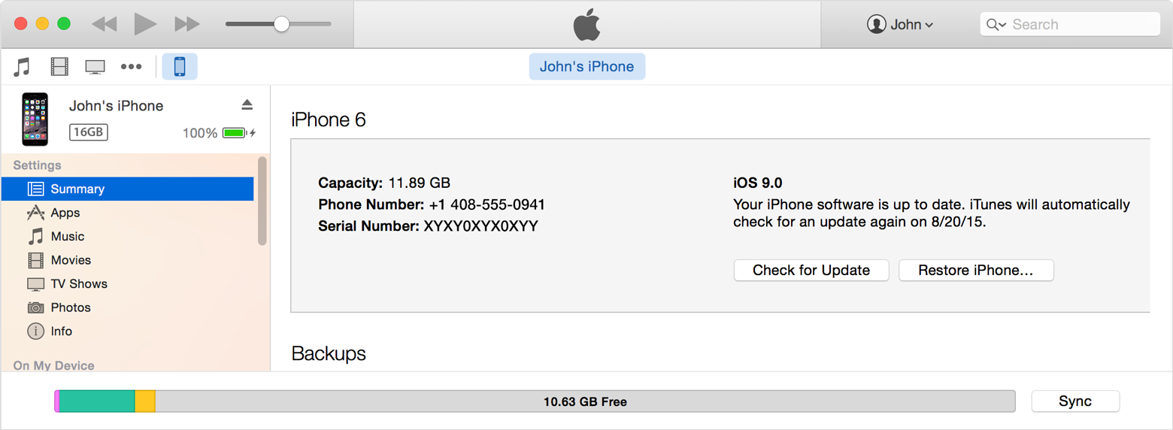

- Click Download and Update.

